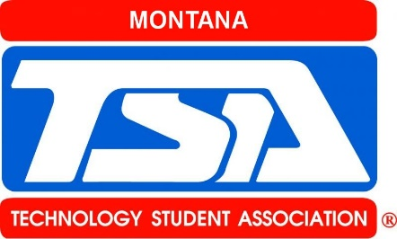**Montana Technology Student Association**

Chris DePuydt - President

PO Box 232

Saco MT, 59261

Cell: 406.390.4109

E-mail: [chrispcrane34@gmail.com](mailto:chrispcrane34@gmail.com)

[Date]

Dear Mr./Ms.[name of representative from business]:

We are the state officer team of the Montana Technology Student Association (TSA). We would like to invite a representative from [name of business] to attend the **Montana TSA State Leadership Conference** on April 11th- 12th. We believe that having your representative attend our state event would help our members to better understand your business and its workforce needs, as well as provide your organization with information about TSA’s role in career and technical education.

The Technology Student Association is a national, non-profit career and technical student organization (CTSO), recognized by the U.S. Department of Education. TSA prepares middle school and high school students for careers in science, technology, engineering, and mathematics (STEM). We have over 190,000 members in over 2,000 chapters across the United States. Our state association has [state membership count] members, with [TSA event attendance] attending the TSA State Leadership Conference.

As a state officer team, we understand that [name of business] shares our interest in creating a workforce that is ready for the future. Thus, we cordially invite you to the TSA State Leadership Conference held April 11th- 12th, starting at 9:30 AM in the Montana Pavilion, Metra Park, Billings, MT. At the State Leadership Conference, you will be able to interact with TSA members, watch them engage in various science, technology, engineering, and mathematics (STEM) events, and discover for yourself why thousands of students across the country see TSA as a creative, exciting, and important extension of their STEM education.

If you have any questions, please contact [state advisor] at [state advisor’s email and phone number]. We hope to see you at the Montana TSA State Leadership Conference.

Thank you,

Montana TSA State Officer Team